MOBILE PHONE BASED MOTOR BIKE LOCKING SYSTEM

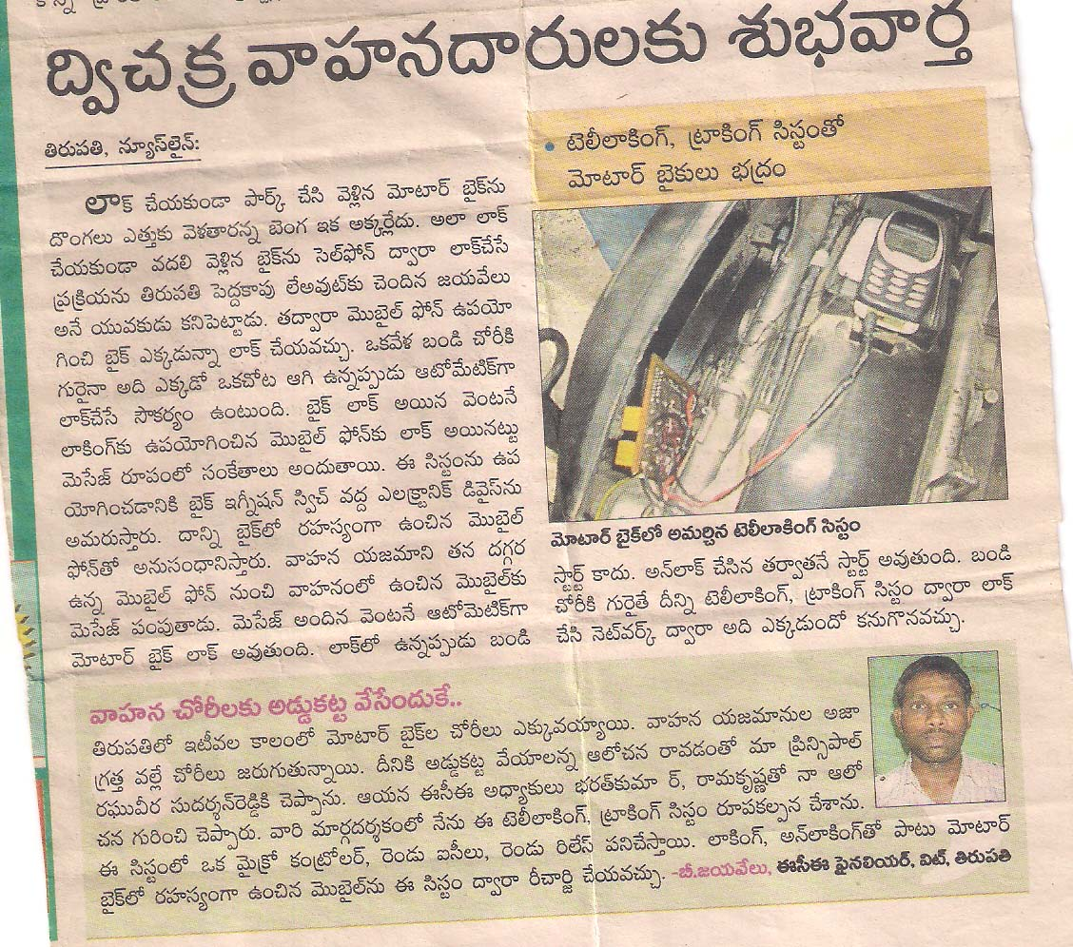

Article published about me in Telugu largest daily Newspaper Sakshi , June 2012.

The project is all about locking Motor Bike with the help of a simple SMS from the owner mobile phone. The Motor bike could be locked from anywhere in this world. the Motor bike Contains a Receiver that replies to the owner mobile phone whether it is locked or not. Whenever it is stolen by anyone, if the owner sends an SMS to the Motor bike it gets locked and sends the reply to owner mobile phone.

PROJECT PICTURIZATION
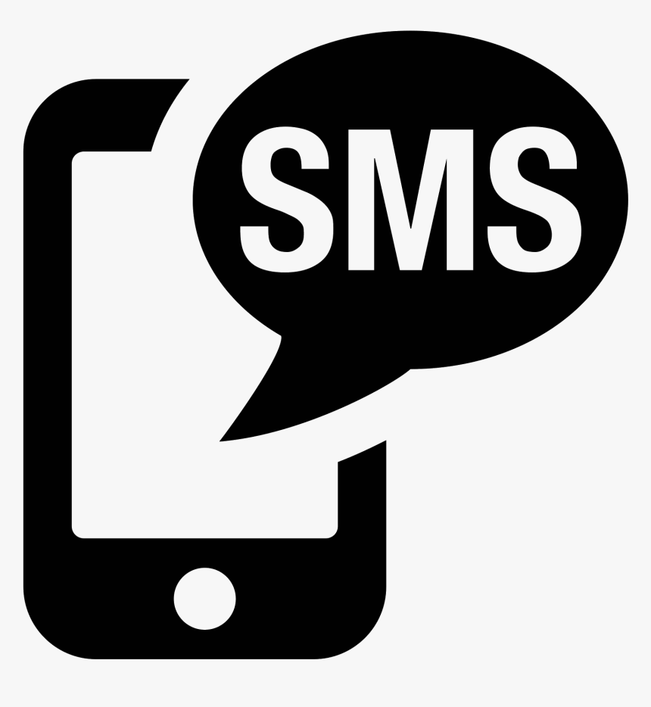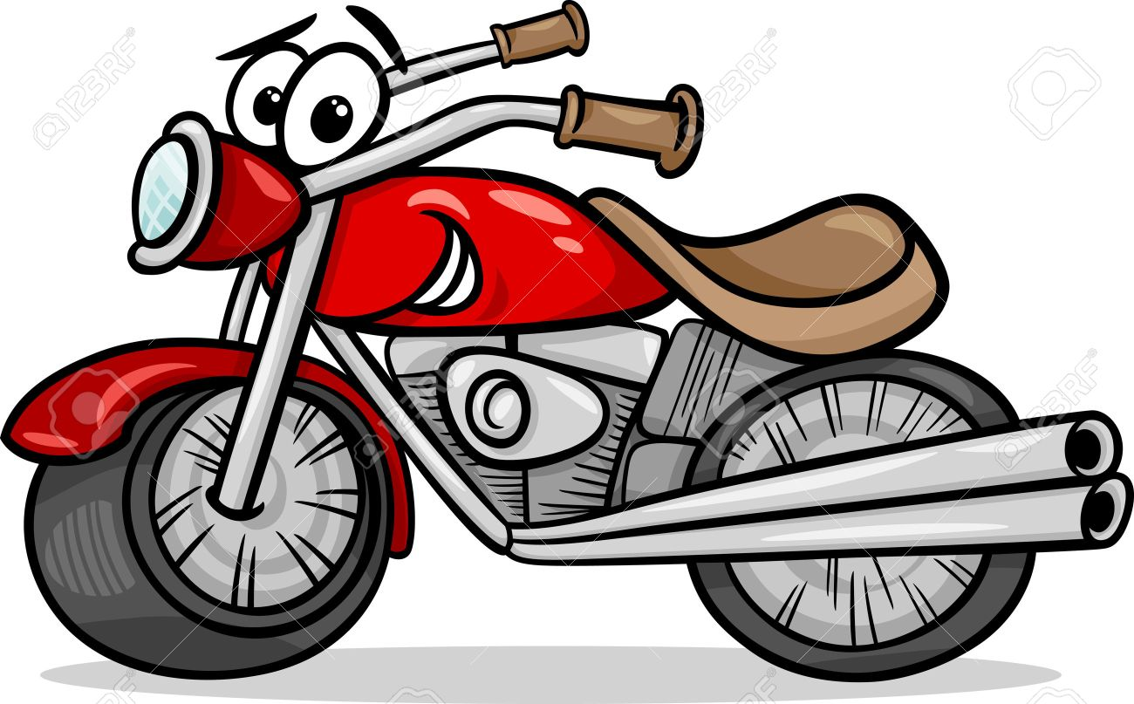

LOCK
LOCKED
UNLOCK
UNLOCKED

